A Project Report for the Bachelor’s in Computer Application
Nepse Pro


Name | Registration No. | Symbol No.
Raghav Panthi | 2023-1-53-0370 | 23530222
Sishir Devkota | 2023-1-53-0220 | 23530121
Shuprabha Mainali | 2023-1-53-0221 | 23530122

School of Environmental Science and Management
Faculty of Science and Technology
Pokhara University, Nepal

July 2025

A Project Report for the Bachelor’s in Computer Application
NEPSE Pro

Supervised by
Mr. Sumant Yadav
A project submitted in partial fulfilment of the requirements for the degree of project for the Bachelor in Computer Application.

Name | Registration No. | Symbol No.
Raghav Panthi | 2023-1-53-0370 | 23530222
Sishir Devkota | 2023-1-53-0220 | 23530121
Shuprabha Mainali | 2023-1-53-0221 | 23530122

School of Environmental Science and Management
Faculty of Science and Technology
Pokhara University, Nepal

July 2025

DECLARATION
We hereby declare that this study entitled Nepse Stock Market Analysis & Portfolio Management Tool (NEPSE Pro) is based on our original research work. Related works on the topic by other researchers have been duly acknowledged. The project documentation in this report was mobilized by three below-mentioned sixth semester undergraduate students of Bachelor of Computer Application (BCA) for the partial fulfillment of the requirement for the project of the sixth semester under the supervision of Sumant Yadav.
Any kind of reproduction of the project and its part for commercial purposes is strictly prohibited without prior written permission of the author and university. However, this report is open for any kind of academic purpose.

………………………….
Raghav Panthi
PU Regd. No. : 2023-1-53-0370

…………………..………
Sishir Devkota
PU Regd. No. : 2023-1-53-0220

…………………………..
Shuprabha Mainali
PU Regd. No. : 2023-1-53-0221

Date: ………………………

CERTIFICATE

RECOMMENDATION
This is to certify that this project entitled Nepse Stock Market Analysis & Portfolio Management Tool (NEPSE Pro) prepared and submitted by Raghav Panthi, Sishir Devkota and Shuprabha Mainali, in partial fulfillment of the requirements of the degree of Bachelor’s in Computer Application awarded by Pokhara University, has been completed under my supervision. I recommend the same for acceptance by Pokhara University.

………………………..

Sumant Yadav
(Supervisor)
School of Environmental Science and Management
Date: …………………….

APPROVAL CERTIFICATE
This project entitled Nepse Stock Market Analysis & Portfolio Management Tool (Nepse Pro) prepared and submitted by Raghav Panthi, Sishir Devkota and Shuprabha Mainali has been examined by us and is accepted for the award of the degree of Bachelor’s in Computer Application by Pokhara University.

…………………… ……………………… ……………………..
External examiner Signature Date

…………………. ……...……………… ……………………..
Supervisor Signature Date

……………………. ………………………. ………………………
HOD Signature Date

ACKNOWLEDGEMENT
All the members of the group have equally contributed to the completion of this project entitled NEPSE Stock Market Analysis & Portfolio Management Tool (Nepse Pro). Foremost, we would like to thank Pokhara University and School of Environmental Science and Management for assigning this type of project which would help in our future development. We are also thankful to Sumant Yadav, the project supervisor for his guidance and support throughout the project.
We would also like to express our sincere thanks to Avishranta Aryal, for his help and interest in our project and also for providing us with his valuable suggestions for the improvement of this project. Additionally, we would like to express our gratitude to all our teachers, seniors, and friends for their support and guidance.
Thanking from

………………………….
Raghav Panthi
PU Regd. No. : 2023-1-53-0370

…………………..………
Sishir Devkota
PU Regd. No. : 2023-1-53-0220

…………………………..
Shuprabha Mainali
PU Regd. No. : 2023-1-53-0221

Date: ………………………

ABSTRACT
The Nepse Stock Market Analysis & Portfolio Management Tool (Nepse Pro) is a web-based stock market analysis and portfolio management system for Nepal Stock Exchange (NEPSE) investors. It provides live market data, interactive charts with technical indicators, virtual trading with Nepal-compliant transaction charges, and portfolio performance tracking.

Keywords: Nepal Stock Exchange (NEPSE), Stock Market Analysis, Portfolio Management, Virtual Trading, Technical Indicators, React, TypeScript, Express.js, SQLite, Financial Analysis, Investment Simulation.

LIST OF ABBREVIATIONS
API | Application Programming Interface
BCA | Bachelor's in Computer Application
CGT | Capital Gains Tax
CORS | Cross-Origin Resource Sharing
CSS | Cascading Style Sheet
DFD | Data Flow Diagram
DP | Depository Participant
EMA | Exponential Moving Average
ER | Entity-Relationship
HTML | Hyper Text Markup Language
JS | JavaScript
JWT | JSON Web Token
LTP | Last Traded Price
MACD | Moving Average Convergence Divergence
NEPSE | Nepal Stock Exchange
NPR | Nepalese Rupee
OHLC | Open, High, Low, Close
OOP | Object-Oriented Programming
ORM | Object Relational Mapper
OTP | One-Time Password
REST | Representational State Transfer
RSI | Relative Strength Index
SEBON | Securities Board of Nepal
SMA | Simple Moving Average
SMTP | Simple Mail Transfer Protocol
SQL | Structured Query Language
SSO | Single Sign-On
UI/UX | User Interface / User Experience
UML | Unified Modeling Language
URL | Uniform Resource Locator

LIST OF TABLES
Table 3.1: Requirement Prioritization Table 10
Table 3.2: Project Scheduling 11

LIST OF APPENDICES
Appendix 1: Project Structure”vscode” 41
Appendix 2: Executing Program on Powersell 41
Appendix 3: App Running on Local Host 41
Appendix 4: Data base 41
Appendix 5: Registration Page 42
Appendix 6: Sign in though Google OAuth Page 42
Appendix 7: Sign in though creating account 42
Appendix 7: OTP for Email Verification 43
Appendix 9: Nepse API 44
Appendix 10: Dashboard 44
Appendix 11: Charts View without indicators 44
Appendix 14:Editing cash balance 46
Appendix 15: Buying stock 46
Appendix 19: Before adding Watchlist 48

TABLE OF CONTENTS
DECLARATION 2
CERTIFICATE 3
RECOMMENDATION 4
APPROVAL CERTIFICATE 5
ACKNOWLEDGEMENT 6
ABSTRACT 7
LIST OF ABBREVIATIONS 8
LIST OF TABLES 10
TABLE OF CONTENTS 12
CHAPTER 1 13
INTRODUCTION 14
1.1 Background 14
1.2 Objectives 14
1.3 Purpose, Scope, and Applicability 15
1.3.1 Purpose 15
1.3.2 Scope 15
1.3.3 Applicability 16
1.4 Achievements 16
1.5 Organization of Report 18
CHAPTER 2 18
SURVEY OF TECHNOLOGIES 19
2.1 Review of Similar/Relevant Projects 19
Analysis of Existing Platforms 19
Research Gap 20
How NEPSE Pro Addresses These Gaps 20
CHAPTER 3 20
REQUIREMENTS AND ANALYSIS 20
3.1 Problem Definition 20
3.2 Requirements Specification 21
3.3 Planning and Scheduling 23
3.4 Software and Hardware Requirements 24
3.5 Preliminary Product Description 25
3.6 Conceptual Models 26
3.6.1 Use Case Diagram 26
3.6.2 Data Flow Diagram — Level 0 (Context Diagram) 27
3.6.3 Data Flow Diagram — Level 1 28
CHAPTER 4 : DESIGN 31
4.1 Introduction 31
4.2 System Design 31
4.3 Database Design 33
4.4 Interface Design 34
4.5 Summary 34
CHAPTER 5 35
IMPLEMENTATION AND TESTING 36
5.1 Implementation Approaches 36
5.1.1 Frontend Architecture 36
5.1.2 Backend Architecture 36
5.2 Coding Details and Code Efficiency 37
5.2.1 Code Efficiency 37
5.3 Testing Approach 38
5.3.1 Unit Testing 38
5.3.2 Integrated Testing 39
5.3.3 Beta Testing 40
5.4 Modifications and Improvements 40
5.5 Test Cases 41
CHAPTER 6 43
RESULTS AND DISCUSSION 44
6.1 Test Reports 44
6.2 User Documentation 45
CHAPTER 7 47
CONCLUSIONS 48
7.1 Conclusion 48
7.1.1 Significance of the System 48
7.2 Limitations of the System 49
7.3 Future Scope of the Project 49
REFERENCE 51
APPENDICES 52

CHAPTER 1

INTRODUCTION

1.1 Background
Nepal Stock Exchange (NEPSE) is the only stock exchange in Nepal where companies list their shares for trading. Every day, thousands of investors buy and sell stocks through NEPSE. Just like stock markets in other countries, NEPSE generates a huge amount of data every single day, including prices, trading volumes, company information, and market trends.
However, getting this information in an easy-to-understand way has always been a challenge for regular investors in Nepal. Most people who want to invest in the stock market find it hard to study patterns and make good decisions because the data is either hard to access or presented in a complicated way. In many cases, investors must depend on multiple websites, social media discussions, or unofficial sources to understand market conditions. This often creates confusion and increases the risk of making poor investment decisions. Beginners especially face difficulties in understanding market trends, price fluctuations, and company performance due to the lack of proper visualization tools and simplified analysis systems.
NEPSE Pro is the implemented solution to this problem - a full-stack web application that shows NEPSE stock market data in an easy-to-understand visual format. Investors can see interactive candlestick price charts with technical indicators, track their favorite companies through a personal watchlist, and manage their investment portfolio with Nepal-specific brokerage charge calculations, all in one place. The system helps users compare stock performance, monitor daily market activities, and analyze historical trends through interactive charts and graphs. By combining real-time market data, advanced charting, and portfolio simulation into a single platform, NEPSE Pro makes stock analysis faster, easier, and more accessible for ordinary investors in Nepal.
The application is built using React Vite and Express.js as its core technologies, with a SQLite database for persistence. It is deployed publicly with the frontend on Vercel and the backend API on Render, making it accessible to any user with a modern browser and internet connection.

1.2 Objectives
The main objectives of this project are:
- To collect and display real-time and historical NEPSE stock market data.
- To provide interactive candlestick charts with technical indicators (SMA, EMA, RSI, and MACD).
- To develop a virtual portfolio management system with profit/loss tracking.
- To calculate Nepal-specific trading charges, including broker commission, SEBON fees, DP charges, and Capital Gains Tax.
- To implement a personalized watchlist for monitoring selected stocks.

1.3 Purpose, Scope, and Applicability

1.3.1 Purpose
The purpose of NEPSE Pro is to make stock market information accessible to everyone in Nepal, whether they are experienced traders or just starting to learn about investing. By presenting complex market data in clean visual charts and graphs, and by combining official NEPSE data with modern personalized features, the application helps ordinary people in Nepal make better, more informed decisions when investing in the stock market.

1.3.2 Scope
What the system does:
- Displays live NEPSE index value, market summary (turnover, market capitalization, traded volume, total transactions), top gainers, and top losers on a real-time dashboard.
- Provides interactive candlestick charts for any NEPSE-listed security across eight timeframes (1m, 5m, 15m, 1h, 4h, 1D, 1W, 1M) with volume histogram, SMA, EMA, RSI, and MACD indicators.
- Allows users to search all NEPSE-listed securities by symbol or company name.
- Provides a full sortable and searchable market watch table for all actively traded scrips.
- Allows registered users to maintain a personal watchlist with live prices refreshed every 30 seconds.
- Allows registered users to simulate buying and selling stocks from a starting virtual cash balance of Rs. 1,00,000, with all Nepal-specific charges automatically calculated.
- Displays current portfolio holdings, average buy price, current value, unrealized P&L, and transaction history.
- Supports user registration with email OTP verification, Google OAuth login, and profile management.
- Works responsively on both desktop computers and mobile phones.
- Stores each user's data securely, so they see only their own watchlist, portfolio, and transactions.
What the system does NOT do:
- This is not a real trading platform — users cannot actually buy or sell stocks through this application.
- This does not connect to bank accounts or payment systems.
- This does not provide financial advice or investment recommendations.
- This does not predict future stock prices.
- This does not support mobile native apps (iOS/Android) — it is a browser-based web application only.

1.3.3 Applicability
NEPSE Pro is applicable to:
- Retail investors in Nepal who wish to track NEPSE market movements and evaluate trade decisions before placing real orders through their broker.
- Finance students studying stock market analysis within the Nepali market context.
- New investors want to practice trading strategy without financial risk, using the virtual cash balance.
- Experienced traders needing a convenient browser-based tool to apply technical analysis to NEPSE-listed securities.

1.4 Achievements
The following were successfully achieved during the development and deployment of NEPSE Pro:
- Full-stack application deployed publicly: Frontend deployed on Vercel (nepse-pro.vercel.app) and backend API on Render (nepse-pro-backend.onrender.com), accessible 24/7.
- Real-time NEPSE market data integration: Integrated the @rumess/nepse-api library with a 5-second in-memory cache to deliver live NEPSE index, market summary, securities list, gainers, losers, and turnover data with minimal external API overhead.
- Professional-grade charting engine: Built a TradingView-inspired chart component using Lightweight Charts with 8 timeframes, 4 technical indicators (SMA, EMA, RSI, MACD), real-time 5-second chart updates during intraday sessions, configurable indicator parameters, and a drawing tools toolbar.
- Nepal-compliant transaction charge engine: Implemented a dedicated charge calculator module correctly applying the SEBON 5-tier broker commission structure, 0.015% SEBON regulatory fee, Rs. 25 fixed DP charge per sell, and CGT at 7.5% (short-term) or 5% (long-term) on realized profit.
- Dual authentication system: Implemented both local email registration with 6-digit OTP verification (via Gmail SMTP using Nodemailer) and Google OAuth 2.0 (via Passport.js), with JWT-based session management for all protected routes.
- FIFO portfolio engine: Built a Portfolio Service class that reconstructs current holdings from ordered transaction history using an average cost method, computes realized P&L on each sell and enforces balance/quantity constraints at trade execution time.
- Responsive dark-themed UI: Implemented a fully dark-themed, mobile-responsive interface using Tailwind CSS 4 with custom CSS properties, providing a professional trading platform aesthetic.
- Bug identified and fixed: Beta testing revealed that the NEPSE index was displaying the close field (previous session snapshot) rather than currentValue (live value) from the API response. This was corrected across all three affected components, and the index cache TTL was extended to 60 seconds to reduce unnecessary API calls.

1.5 Organization of Report
This report is organized as follows:
- Chapter 1 – Introduction: Provides background context, project objectives, scope, applicability, key achievements, and report organization.
- Chapter 2 – Survey of Technologies: Reviews existing platforms (NEPSE website, Merolagani, ShareSansar, TradingView) and the technologies and frameworks selected for NEPSE Pro.
- Chapter 3 – Requirements and Analysis: Defines the problem, specifies functional and non-functional requirements with prioritization, presents the project timeline (Gantt chart), hardware/software requirements, budget, preliminary product description, and conceptual models (Use Case Diagram, DFD Level 0 and Level 1).
- Chapter 4 – Design: Covers system architecture, API endpoint design, database design (ER diagram, schema tables), UML class and sequence diagrams, and interface wireframes.
- Chapter 5 – Implementation and Testing: Details the implementation approach, code structure, charge calculation logic, code efficiency, testing strategy (unit, integration, beta), modifications made during development, and test cases.
- Chapter 6 – Results and Discussion: Presents the test report summary and complete user documentation.
- Chapter 7 – Conclusions: Summarizes conclusions, the significance of the system, current limitations, and future scope for extension.

CHAPTER 2

SURVEY OF TECHNOLOGIES

2.1 Review of Similar/Relevant Projects
Before developing NEPSE Pro, it was essential to study Nepal's existing stock market platforms. Analyzing their strengths and weaknesses helps identify missing features and clarifies how NEPSE Pro can improve the investor experience.
Currently, most local investors rely on the Official NEPSE Website, Merolagani, and ShareSansar for market data, while some use international platforms like TradingView for advanced technical analysis. While these tools are useful, each has distinct limitations that impact the overall user experience—creating a clear opportunity for NEPSE Pro.
Table 2.1: Comparison of Existing NEPSE Platforms
Platform | Features Offered | Limitations
Official NEPSE Website(nepalstock.com) | Contains all official data, trustworthy information | Very complicated to use, looks old-fashioned, hard for beginners, no personal features like watchlist or portfolio tracking
Merolagani.com | Shows news, company information, and basic charts | Charts are basic and not interactive; no portfolio management; cluttered with ads; paid services are expensive
ShareSansar.com | Provides market news and data | Not mobile-friendly, limited charting features, no personalized experience
TradingView (Global) | Professional-grade charting, 100+ indicators, social trading | Does not support NEPSE data natively; no Nepal-specific charge calculation; paid subscription required for full features

Analysis of Existing Platforms
The Official NEPSE Website is the most reliable source of market information but is not easy to use, especially for beginners. Merolagani and ShareSansar provide useful news and company information, but they offer limited analytical and personalized features. TradingView is excellent for technical analysis; however, it is designed for global markets and does not fully support the Nepalese stock market.

Research Gap
The review shows that current platforms mainly focus on either providing market information or technical analysis. None offer both together with personalized investment tools.
The main gaps identified are:
- Lack of a modern and user-friendly interface.
- No personalized watchlist or dashboard.
- Limited portfolio management features.
- No accurate NEPSE brokerage and tax calculation.
- Limited technical analysis based on NEPSE data.
- Users need to switch between multiple websites to perform different tasks.

How NEPSE Pro Addresses These Gaps
NEPSE Pro brings all essential investment tools into a single platform. It provides real-time NEPSE data, interactive candlestick charts with technical indicators, personalized watchlists, a portfolio simulator, and automatic calculation of brokerage fees and taxes based on NEPSE rules.
Overall, NEPSE Pro offers a simple, modern, and Nepal-focused solution that helps investors analyze the market, manage their portfolios, and make informed investment decisions without relying on multiple platforms.

CHAPTER 3

REQUIREMENTS AND ANALYSIS

3.1 Problem Definition
The current state of NEPSE stock data tools is fragmented and inadequate for the average retail investor in Nepal. Platforms like Merolagani, ShareSansar, and the official NEPSE website provide basic price listings and news but fall well short of what modern investors need. The core problems are:
1. Data is hard to understand:
Raw stock prices mean nothing to most people. Seeing “NBL” at Rs. 450” does not tell you if that is good or bad. Investors need visual charts to understand price movements and trends.
2. No personal tracking:
Investors must manually maintain Excel sheets or notebooks to track which stocks they own and at what price. This is messy, error-prone, and does not account for the real cost of transactions (brokerage, SEBON fees, taxes).
3. No easy watchlist:
When researching, investors find interesting companies but have no way to save them for quick reference on their next visit. Every session starts from scratch.
4. No charge-aware portfolio simulation:
No free existing platform automatically calculates the real cost of NEPSE trades — including the tiered broker commission structure, SEBON regulatory fees, DP charges, and capital gains tax — so investors have no accurate picture of their true returns.
5. Complex interface:
Existing websites display too much raw technical information that confuses beginners. A person looking to invest their savings finds it overwhelming.
6. Not mobile-friendly:
Most existing tools work only on desktop computers. People want to check the market on their phones while traveling or at work.

3.2 Requirements Specification
To develop the Nepse Pro, we first identified what the system should do and how it should perform. These requirements are grouped into two categories:
3.2.1 Functional Requirements
Functional requirements define the essential operations that the NEPSE Pro system must perform. The system enables users to access real-time NEPSE market data, analyze stocks using interactive charts and technical indicators, manage watchlists and virtual portfolios, and securely manage their accounts through a user-friendly interface.
- The system should allow users to register, verify their email, and log in securely.
- The system should display real-time NEPSE index, market summary, top gainers, top losers, and a complete market watch.
- The system should provide interactive candlestick charts with multiple timeframes and technical indicators.
- The system should allow users to search for stocks by company name or symbol.
- The system should allow users to create and manage a personal watchlist with regularly updated stock prices.
- The system should allow users to simulate buying and selling stocks while automatically calculating transaction charges.
- The system should display portfolio holdings, profit/loss, and transaction history.
- The system should allow users to update their profile, change their password, and log out securely.

3.2.2 Non-Functional Requirements
Non-functional requirements define the quality, security, and performance standards of the NEPSE Pro system to ensure a reliable and efficient user experience.
- The system should provide fast performance with quick response times.
- The system should ensure secure authentication and data protection.
- The system should display accurate and reliable NEPSE market data.
- The system should be stable and handle errors without crashing.
- The system should be responsive across desktop and mobile devices.
- The system should accurately calculate all trading charges.
- The system should be easy to maintain and support future enhancements.

3.2.3 Requirements Prioritization Table
This table categorizes all system requirements based on their importance and urgency. It helps the development team identify which functionalities should be implemented first and which can be postponed for later development phases. This prioritization ensures that the most critical aspects of the system are addressed early in the project lifecycle.
Table 3.1: Requirement Prioritization Table
Requirement | Priority | Justification
Real-Time Stock Price Display | High | Core function; primary reason users visit the platform
NEPSE Index & Sub-Index View | High | Essential market overview; mandatory for any stock tool
Historical Price Charts | High | Required for trend analysis and investment decisions via Lightweight Charts
Portfolio Management Module | High | Differentiates this tool from simple price-listing sites
Top Gainers / Losers | High | Quick daily market overview; expected by all investors
Stock Search by Name/Symbol | High | Critical for navigation with hundreds of listed companies
Watchlist Feature | High | Allows personalized tracking; saves users repeated searching
Charge Calculation (Nepal-specific) | High | Unique feature not found in any free existing platform
Technical Indicators (SMA/EMA/RSI/MACD) | Medium | Useful for advanced users; not critical for all visitors
Google OAuth Login | Medium | Useful for convenience; email login covers the core need
Sector-Wise Analysis View | Medium | Improves depth of analysis; can be added in a later phase

3.3 Planning and Scheduling
Before starting the development of the Nepse Pro, we created a simple plan to guide our work. The project was divided into phases to manage time and tasks effectively:
Table 3.2: Project Scheduling
Phase | Task | Duration
Planning | Requirement analysis & research | May 10-May 12
Design | UI layout, flowcharts | May 12-May 15
Frontend Development | HTML, CSS, JS pages | May 15-May 21
Backend Development | Java Spring boot | May 31-June 02
Database Integration | MySQL integration | June 10-June 15
Testing | Functional testing & bug fixing | May 13-June 10
Documentation | Documentation, review | June 0-June 23
Deployment | Handover | June 07-jun-10

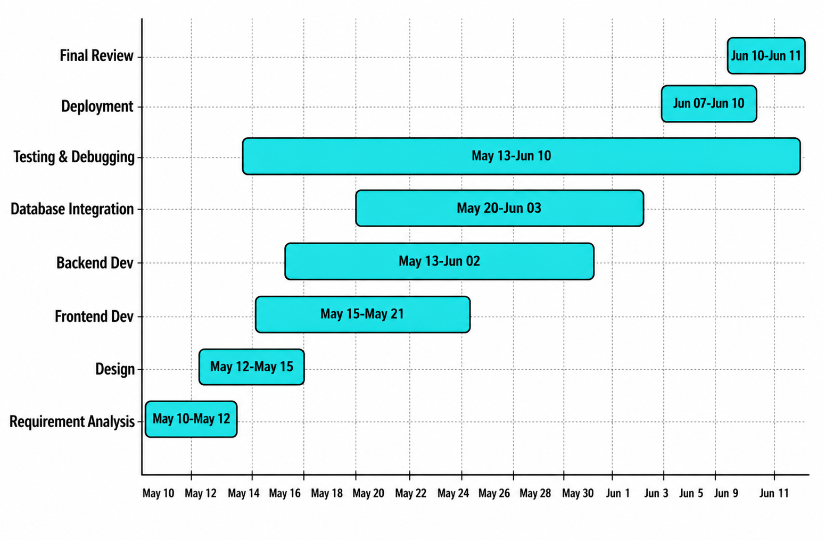
Figure 3.1: Gantt Chart

3.4 Software and Hardware Requirements
To run and develop the TravelEase, the following software and hardware requirements were identified:
Software Requirements
- To develop and run the NEPSE Pro system, the following software requirements were identified.
- Operating System: Windows 10/11, macOS, or Linux
- Runtime: Node.js v22.12.0
- Package Manager: npm v10+
- Version Control: Git / GitHub
- Code Editor: Visual Studio Code
- API Testing: Postman / Thunder Client
- Web Browser: Google Chrome, Firefox, or Safari
- Design Tool: Figma
- Database: SQLite (DB Browser for SQLite)
Hardware Requirements
- Processor: Dual-core 2.0 GHz or above
- Memory: Minimum 4 GB RAM (8 GB recommended)
- Storage: At least 10 GB free disk space
- Network: Stable broadband internet connection
- Display: Minimum resolution of 1280 × 720
Development Cost Estimation
The estimated development cost for NEPSE Pro is minimal because open-source technologies and personal devices were used throughout the project.
- Development and testing using personal laptops – Rs. 0
- Open-source software (Node.js, React, Express.js, TypeScript, Tailwind CSS, SQLite, Git, VS Code) – Rs. 0
- Hosting using Vercel free tier – Rs. 0
- Domain using Vercel subdomain – Rs. 0
- Printing and report binding – Approximately Rs. 500
Total Estimated Cost: Rs. 500

3.5 Preliminary Product Description
NEPSE Pro is a web-based stock market analysis and portfolio management system that follows a client-server architecture consisting of two main components: the backend and the frontend.
Backend
The backend is developed using Node.js, Express.js, and TypeScript, with SQLite as the database. It provides RESTful APIs for user authentication, NEPSE market data, watchlists, portfolios, and virtual trading. User authentication is secured using JWT, bcrypt, Google OAuth 2.0, and Email OTP verification.
Frontend
The frontend is built using React, TypeScript, Vite, and Tailwind CSS. It communicates with the backend through REST APIs and provides an interactive interface for viewing market data, analyzing charts, managing watchlists, simulating trades, and maintaining user profiles.
Project Structure
nepse-pro/
├── backend/
│ ├── routes/
│ ├── middleware/
│ ├── services/
│ ├── utils/
│ └── package.json
├── frontend/
│ ├── pages/
│ ├── components/
│ ├── utils/
│ └── package.json
The backend handles business logic, authentication, database operations, and NEPSE data integration, while the frontend provides the user interface and communicates with the backend through secure REST API requests.

3.6 Conceptual Models

3.6.1 Use Case Diagram
Figure 3.2: Use Case Diagram of NEPSE Pro
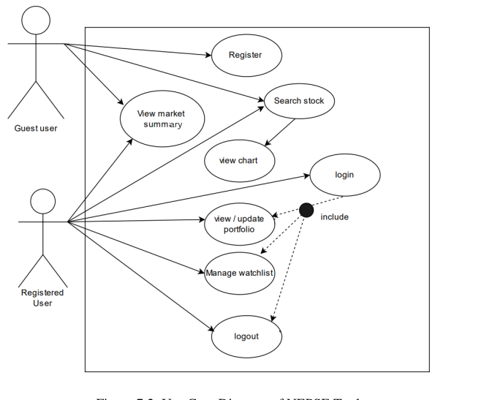Explanation:
The diagram represents the Nepse Pro, showing how users interact with it. There
are two actors: Registered User and Guest User.
- Registered User log in, and access all features including a market summary, watchlist, and portfolio.
- Guest User can only Register search stocks and view charts.
The system includes use cases like Search Stock, View Charts, Manage Watchlist and View Portfolio. The «include» relationship shows that Logout, Manage Watchlist and View Portfolio require the user to log in.

3.6.2 Data Flow Diagram — Level 0 (Context Diagram)
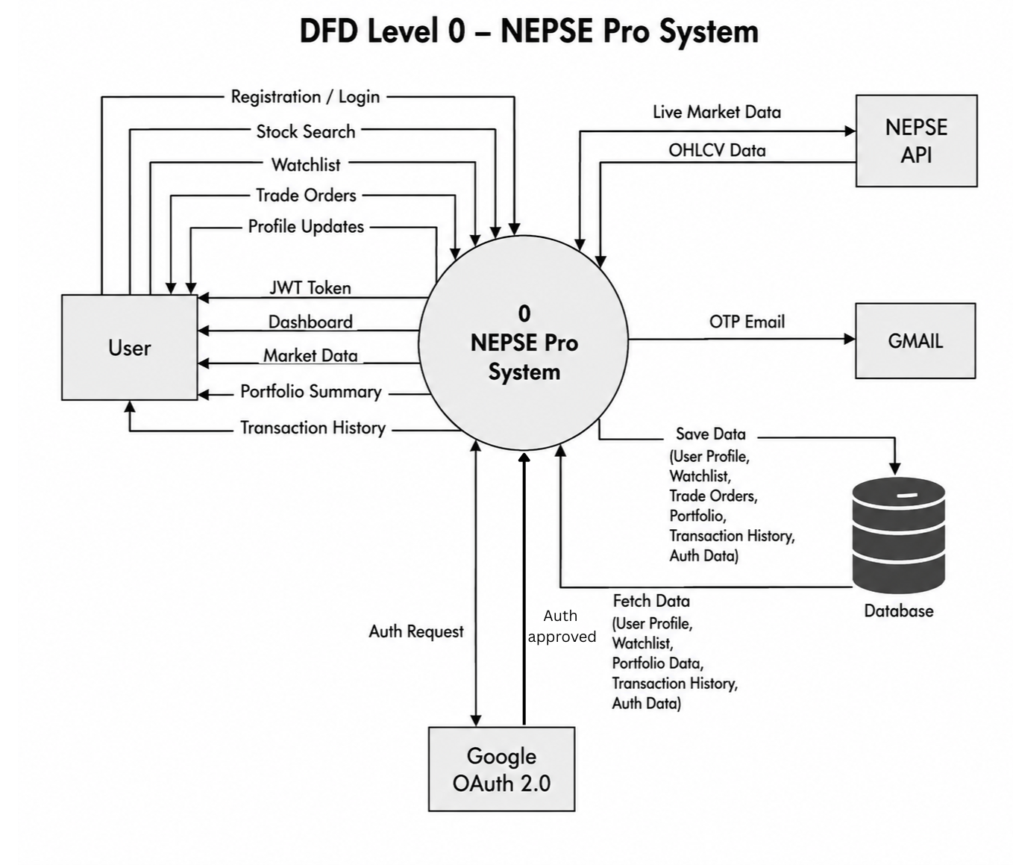
Explanation:
The diagram represents the Level 0 Data Flow Diagram (DFD) of the NEPSE Pro system, showing the flow of data between the user, the system, and external services. Users can register, log in, search stocks, manage watchlists, perform virtual trading, and update their profiles. After successful authentication, the system provides access to the dashboard, market data, portfolio summary, and transaction history.
The system retrieves live market data from the NEPSE API, sends OTP verification emails through Gmail, and supports secure login using Google OAuth 2.0. All user information, including profiles, watchlists, portfolios, and transaction history, is stored in the database. The system processes user requests and communicates with external services to provide secure authentication, accurate market data, and efficient portfolio management.

3.6.3 Data Flow Diagram — Level 1
Figure 3.4: DFD Level 1 – Main Processes of NEPSE Pro
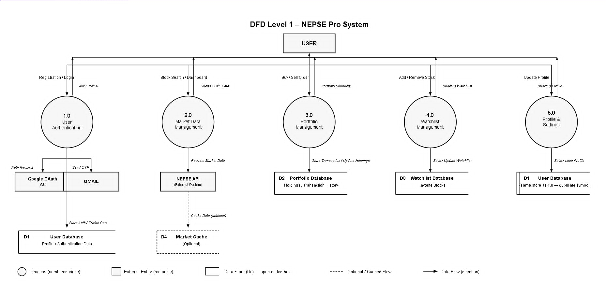
Explanation:
The Level 1 Data Flow Diagram (DFD) illustrates the major processes of the NEPSE Pro system and the flow of data between the user, external services, and databases.
The system consists of five main processes: User Authentication, Market Data Management, Portfolio Management, Watchlist Management, and Profile & Settings. Users register or log in through email or Google OAuth, after which authentication data is stored in the User Database. The system retrieves livestock market data from the NEPSE API and optionally stores it in a cache for faster access. Portfolio transactions and holdings are managed in the Portfolio Database, while favorite stocks are stored in the Watchlist Database. Users can also update their profile information, which is saved in the User Database.
Overall, the Level 1 DFD shows how NEPSE Pro securely manages user authentication, retrieves real-time market data, processes portfolio transactions, maintains watchlists, and stores user information efficiently.

CHAPTER 4 : DESIGN

4.1 Introduction
NEPSE Pro follows a client-server architecture with a clear separation between the React frontend presentation layer and the Express.js backend business logic layer. The database layer uses SQLite for embedded file-based persistence, which is appropriate for the project's current scale. The frontend is served from Vercel's global CDN, and the backend API runs on Render's cloud infrastructure — both connected securely over HTTPS.

4.2 System Design
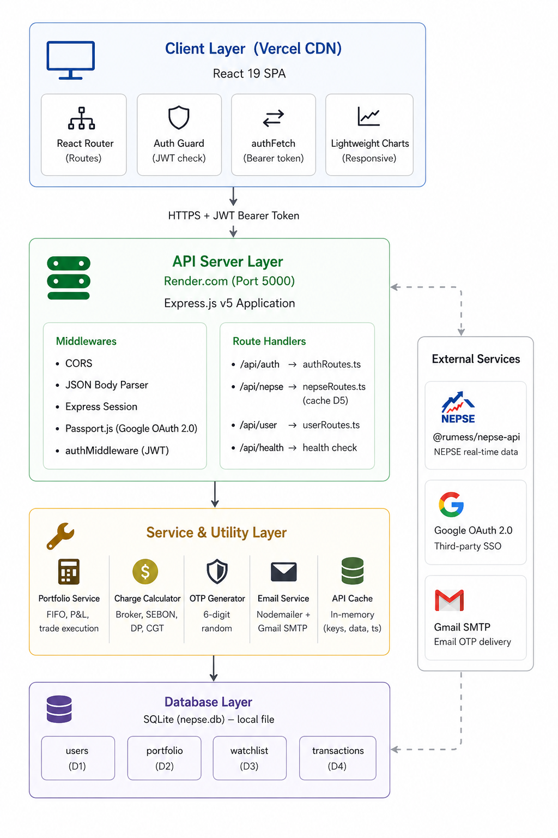
Figure 4.1: System Architecture Diagram
The diagram illustrates the system architecture of the NEPSE Pro application, which follows a multi-layer client-server design. The Client Layer is built using React 19, TypeScript, and Tailwind CSS, providing a responsive user interface with secure route protection and interactive stock charts. The client communicates with the backend through HTTPS using JWT Bearer Tokens for secure authentication.
The API Server Layer is developed with Node.js, Express.js, and TypeScript, where it handles user authentication, market data requests, portfolio management, watchlists, and other business logic through RESTful APIs. Security features such as CORS, JWT authentication, Google OAuth 2.0, and request validation are implemented in this layer.
The Service and Utility Layer performs core application functions, including portfolio calculations, brokerage charge computation, OTP generation, email delivery, and API response caching to improve performance. The system integrates with external services such as the NEPSE API for real-time market data, Google OAuth 2.0 for authentication, and Gmail SMTP for OTP email verification.
The Database Layer uses SQLite to store user accounts, portfolios, watchlists, and transaction history. This layered architecture provides secure authentication, efficient data management, high performance, and easy maintenance while ensuring a scalable and reliable stock market analysis platform.

4.3 Database Design
The NEPSE Pro system uses an SQLite relational database to store user information, watchlists, portfolios, and transaction records. The Users table is the main table and is connected to the Watchlist, Portfolio, and Transactions tables through the user_id foreign key in a one-to-many relationship. The ON DELETE CASCADE constraint automatically removes related records when a user account is deleted.
The database supports secure user management, watchlist tracking, virtual portfolio management, and transaction history while ensuring data consistency and efficient retrieval.

Figure 4.3.1: ER Diagram of NEPSE Pro
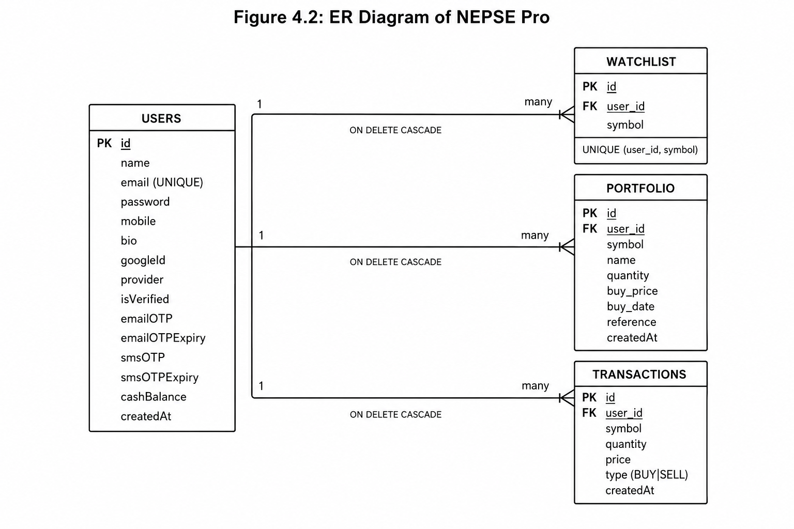

4.4 Interface Design
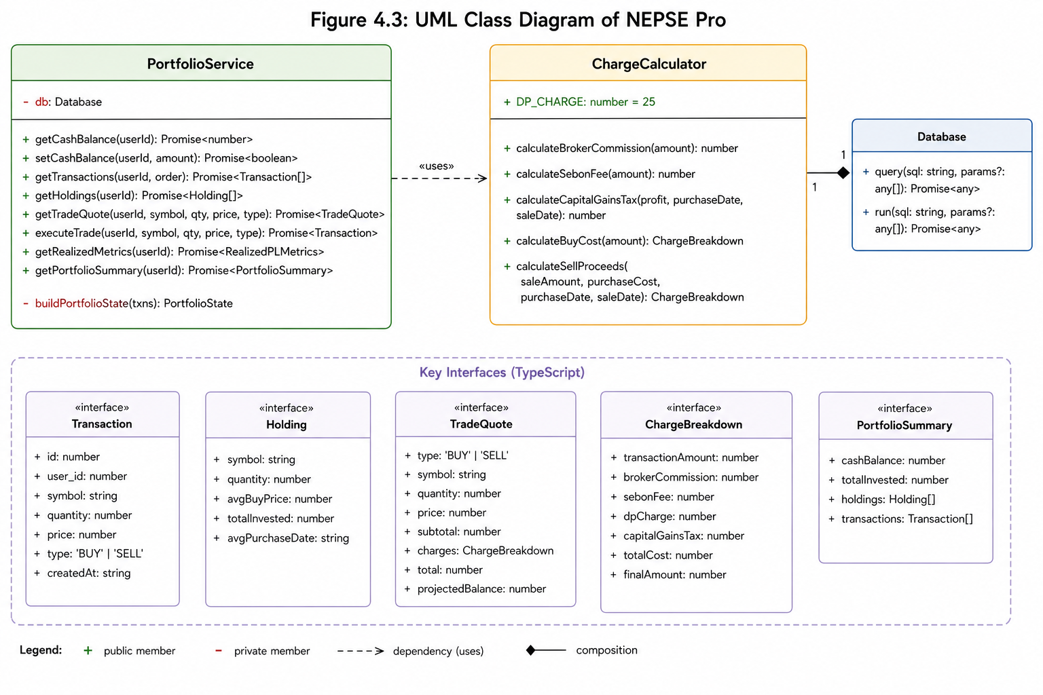Figure 4.3: UML Class diagram of NEPSE Pro

4.5 Summary
The design of NEPSE Pro follows a three-tier client-server architecture, consisting of the frontend, backend, and database layers. The React frontend provides a responsive and interactive interface for accessing market data, charts, watchlists, portfolios, and user profiles. The Node.js and Express.js backend handles user authentication, business logic, REST API requests, and integration with external services such as the NEPSE API, Google OAuth 2.0, and Gmail SMTP. The SQLite database stores user accounts, watchlists, portfolios, and transaction history while maintaining data integrity through relational design.
The system incorporates secure authentication using JWT, bcrypt password hashing, and OTP email verification. It also includes API caching to improve performance and automatically calculates brokerage charges, SEBON fees, DP charges, and Capital Gains Tax (CGT) during virtual trading. Overall, the system design provides a secure, reliable, maintainable, and scalable platform for real-time NEPSE stock market analysis and virtual portfolio management.

CHAPTER 5

IMPLEMENTATION AND TESTING

5.1 Implementation Approaches

5.1.1 Frontend Architecture
The frontend of NEPSE Pro is developed using React 19, TypeScript, Vite, and Tailwind CSS. It follows a component-based architecture, where the application is organized into page components, reusable UI components, and utility functions. This modular structure improves code reusability, readability, and maintainability.
The application uses React Router for navigation between pages such as Dashboard, Market Watch, Charts, Portfolio, Watchlist, and Profile. An Auth Guard mechanism protects authenticated routes by verifying the user's JWT token stored in the browser before granting access. If the token is invalid or missing, the user is redirected to the login page. A Guest Mode is also available, allowing users to access limited features such as the dashboard without creating an account.
All communication with the backend is handled through a custom API utility that automatically attaches the JWT Bearer Token to authenticated requests. If a session expires, the user is redirected to the login page, ensuring secure access to protected resources.

5.1.2 Backend Architecture
The backend of NEPSE Pro is built using Node.js, Express.js, and TypeScript. It exposes RESTful APIs for authentication, market data, portfolio management, watchlists, and user profile management. Middleware such as CORS, JSON body parsing, Express Session, and Passport.js are configured to support secure communication and Google OAuth authentication.
The application uses SQLite as the database. During server startup, the database is automatically initialized by creating the required tables and applying necessary schema updates. A demo account is also created if the database is empty to simplify initial testing.
Authentication is implemented using JWT (JSON Web Tokens). Protected API endpoints verify the user's token before processing requests, ensuring that only authenticated users can access sensitive features such as portfolios, watchlists, and profile information.
To improve performance and reduce unnecessary external API requests, the backend implements an in-memory caching mechanism for NEPSE market data. Frequently requested data is temporarily stored and reused for a short period before requesting fresh data from the NEPSE API, resulting in faster response times and reduced server load.
The backend also integrates with external services, including the NEPSE API for real-time stock market data, Google OAuth 2.0 for secure authentication, and Gmail SMTP for sending OTP verification emails during user registration and password recovery.

5.2 Coding Details and Code Efficiency

5.2.1 Code Efficiency
The NEPSE Pro system is designed with a focus on accuracy, performance, and maintainability. The application uses modular functions to perform trading calculations, portfolio management, and technical analysis while minimizing unnecessary computations.
The system accurately calculates broker commission, SEBON fee, DP charge, and Capital Gains Tax (CGT) according to the official NEPSE and SEBON regulations. Different commission rates are applied based on the transaction amount, while CGT is calculated using separate rates for short-term and long-term investments.

Table 5.1: Broker Commission Tier Structure
Transaction Amount (Rs.) | Commission Rate
Up to 50,000 | 0.36%
50,001 to 5,00,000 | 0.33%
5,00,001 to 20,00,000 | 0.31%
20,00,001 to 1,00,00,000 | 0.27%
Above 1,00,00,000 | 0.24%

The portfolio management module uses a weighted average cost method to calculate the average purchase price of stocks and automatically updates holdings after every buy or sell transaction. It also computes realized and unrealized profit or loss, providing users with accurate portfolio performance.
To improve application performance, all technical indicators, including SMA, EMA, RSI, and MACD, are calculated on the client side using the received market data. This reduces server workload and allows indicator settings to be updated instantly without additional API requests.
The application also implements real-time chart updates by fetching only the latest market data at regular intervals instead of reloading the entire chart. Additionally, API response caching is used on the backend to reduce repeated requests to the NEPSE API, improving response time and reducing external API usage.
Furthermore, the system handles Nepal Standard Time (UTC +5:45) when processing intraday market data, ensuring that stock charts display accurate trading dates and times.
Overall, these implementation techniques improve the system's efficiency, accuracy, responsiveness, and scalability while providing a smooth user experience.

5.3 Testing Approach
Testing was done at different levels to ensure that the system works correctly and is free of major bugs. We followed the following testing strategies:

5.3.1 Unit Testing
Unit testing was conducted to verify the correctness of individual functions and ensure that the core business logic of NEPSE Pro works as expected.
The following components were tested:
- Broker Commission Calculation: Verified commission rates for all NEPSE transaction tiers and boundary values.
- SEBON Fee Calculation: Confirmed the fee is calculated as 0.015% of the transaction amount.
- Capital Gains Tax (CGT): Tested short-term, long-term, and loss scenarios to ensure correct tax calculation.
- Buy and Sell Cost Calculation: Verified the accuracy of broker commission, SEBON fee, DP charge, CGT, and final transaction amount.
- Portfolio Management: Tested multiple buy and sell transactions to ensure correct calculation of holdings, average purchase price, and profit/loss.
The unit tests confirmed that all critical financial calculations and portfolio operations produced accurate and reliable results.

5.3.2 Integrated Testing
- Integration testing was performed to verify that different modules of NEPSE Pro work together correctly, including the frontend, backend, database, and external services.
- The following scenarios were tested:
- User Registration: Verified registration, OTP email verification, and successful account activation.
- User Login: Tested login with valid, invalid, and unverified user accounts.
- Authentication: Verified that only authenticated users can access protected routes using JWT.
- Watchlist Management: Tested adding stocks to the watchlist and preventing duplicate entries.
- Virtual Trading: Verified successful buy and sell transactions, portfolio updates, and balance calculations.
- Error Handling: Tested insufficient balance, insufficient shares, and invalid authentication scenarios.
- Testing Tools Used:
- Postman – API testing
- Browser Developer Tools – Frontend request and response verification

5.3.3 Beta Testing
Beta testing was conducted with a small group of users to evaluate the functionality, usability, and performance of NEPSE Pro.
The following observations were made:
- Market Data Verification: Identified and corrected a discrepancy in the displayed NEPSE index value.
- Trading Charge Accuracy: Verified broker commission, SEBON fee, DP charge, and CGT calculations against official formulas.
- User Interface: Users were able to navigate the dashboard, watchlist, portfolio, and trading features without difficulty.
- Mobile Compatibility: Confirmed smooth operation on desktop, Android, and iOS browsers.
- Real-Time Updates: Verified that watchlist prices refresh automatically without requiring a page to reload.
The beta testing confirmed that the system is reliable, user-friendly, and suitable for real-time NEPSE market analysis and virtual portfolio management.

5.4 Modifications and Improvements
During the development and beta testing of NEPSE Pro, several issues were identified and resolved to improve the system's functionality, performance, security, and user experience.
- NEPSE Index Display Improvement
The dashboard was updated to display the current live NEPSE index instead of the previous session's closing value. API caching was also optimized to reduce unnecessary requests while keeping market data up to date.
- Email OTP Delivery Enhancement
SMTP email configuration was improved to ensure reliable OTP delivery for account verification and password recovery.
- Google OAuth Authentication Validation
Validation was added to verify Google OAuth environment variables before authentication. If the configuration is missing, the system now displays a clear error message instead of failing.
- Database Migration Improvement
A database migration mechanism was implemented to automatically apply schema updates while preserving existing user data, enabling safe deployment of new features.
- Real-Time Chart Data Enhancement
To fix the "one day late" chart issue caused by delayed historical API data, the system now combines live intraday market data with historical OHLCV data to generate an up-to-date candlestick using Nepal Standard Time (UTC +5:45).
Overall, these improvements enhanced the accuracy, reliability, security, and overall performance of NEPSE Pro, making it more stable for real-time stock market analysis.

5.5 Test Cases
Here are some test cases used during the testing phase:
Table 5.2: Unit Test Cases
TC ID | Function | Input | Expected Output | Result
UT-01 | calculateBrokerCommission | Rs. 50,000 | Rs. 180.00 (0.36%) | Pass
UT-02 | calculateBrokerCommission | Rs. 50,001 | Rs. 165.00 (0.33%) | Pass
UT-03 | calculateBrokerCommission | Rs. 5,00,000 | Rs. 1,650.00 (0.33%) | Pass
UT-04 | calculateBrokerCommission | Rs. 5,00,001 | Rs. 1,550.00 (0.31%) | Pass
UT-05 | calculateSebonFee | Rs. 1,00,000 | Rs. 15.00 (0.015%) | Pass
UT-06 | calculateCapitalGainsTax | profit=10,000; days=200 | Rs. 750.00 (7.5%) | Pass
UT-07 | calculateCapitalGainsTax | profit=10,000; days=400 | Rs. 500.00 (5.0%) | Pass
UT-08 | calculateCapitalGainsTax | profit=−2,000; days=100 | Rs. 0 (no tax on loss) | Pass
UT-09 | calculateBuyCost | Rs. 1,00,000 | finalAmount = Rs. 1,00,345 | Pass
UT-10 | buildPortfolioState | 2× BUY + 1× SELL | Correct avgBuyPrice, realizedPL | Pass
UT-11 | buildPortfolioState | SELL quantity > held | Throws error | Pass
UT-12 | buildPortfolioState | Full sell of all shares | Holdings map empty | Pass

Table 5.3: Integration Test Cases
TC ID | Endpoint | Method | Scenario | Expected Response | Result
IT-01 | /api/auth/signup/init | POST | Valid new user data | 201 {userId, requiresVerification: true} | Pass
IT-02 | /api/auth/signup/init | POST | Already verified email | 409 Conflict | Pass
IT-03 | /api/auth/verify/email | POST | Correct OTP within expiry | 200 {token, user} | Pass
IT-04 | /api/auth/verify/email | POST | Expired OTP | 400 'OTP has expired' | Pass
IT-05 | /api/auth/verify/email | POST | Wrong OTP | 400 'Invalid verification code' | Pass
IT-06 | /api/auth/login | POST | Valid credentials, verified account | 200 {token} | Pass
IT-07 | /api/auth/login | POST | Wrong password | 401 'Invalid email or password' | Pass
IT-08 | /api/auth/login | POST | Unverified account | 403 requiresVerification: true | Pass
IT-09 | /api/user/watchlist | POST | Add new symbol (authenticated) | 201 {id, symbol} | Pass
IT-10 | /api/user/watchlist | POST | Add duplicate symbol | 409 Conflict | Pass
IT-11 | /api/user/trade | POST | BUY with sufficient balance | 201 {transaction, tradeQuote} | Pass
IT-12 | /api/user/trade | POST | BUY exceeding cash balance | 400 'Insufficient balance' | Pass
IT-13 | /api/user/trade | POST | SELL without any holdings | 400 'Insufficient shares' | Pass
IT-14 | /api/nepse/index | GET | No parameters | 200 [{index, currentValue, change}] | Pass
IT-15 | Any protected route | GET | No Authorization header | 401 'No token provided' | Pass

CHAPTER 6

RESULTS AND DISCUSSION

6.1 Test Reports
All unit, integration, and beta test cases were executed to verify the functionality, performance, and reliability of NEPSE Pro. The unit and integration tests achieved a 100% pass rate, confirming that the core business logic, API endpoints, and database operations functioned correctly. During beta testing, one issue related to the NEPSE index display was identified and subsequently resolved, resulting in a stable and reliable system.
Table 6.1: Test Report Summary
Test Category | Total Cases | Passed | Failed | Pass Rate
Unit Tests | 12 | 12 | 0 | 100%
Integration Tests | 15 | 15 | 0 | 100%
Beta User Tests | 12 | 11 | 1* | 91.6%
*Note: The single beta testing issue occurred because the dashboard displayed the previous session's NEPSE index instead of the live market value. This issue was corrected during development and is described in Section 5.4 (Modifications and Improvements).
Key Observations from Testing
- Charge Calculation Accuracy: Broker commission, SEBON fee, DP charge, and Capital Gains Tax (CGT) were calculated accurately according to official SEBON rules.
- Authentication Security: OTP verification, JWT authentication, and bcrypt password hashing worked correctly, ensuring secure user authentication.
- Portfolio Management: The portfolio module correctly handled buy and sell transactions, updated holdings, calculated the average purchase price, and generated accurate profit and loss values.
- Market Data Reliability: API caching reduced repeated requests to the NEPSE API, improving response time and reducing external API usage.
- Chart Accuracy: The chart correctly displayed the latest trading day's candlestick using Nepal Standard Time (UTC +5:45), ensuring accurate visualization of live market data.
- Performance: Cached API requests responded in less than 200 ms, while database-backed requests averaged less than 500 ms, meeting the project's performance requirements.
- Responsive Design: The application was successfully tested on desktop and mobile devices, with all major pages functioning correctly across different screen sizes.
Overall Result
The testing results confirm that NEPSE Pro satisfies its functional and non-functional requirements. The system provides accurate market information, secure authentication, reliable portfolio management, and a responsive user interface, making it suitable for real-time NEPSE stock market analysis and virtual trading.

6.2 User Documentation
This section provides a brief guide for using the NEPSE Pro application.
Registration
- Open the NEPSE Pro application in a web browser.
- Click the Sign Up button.
- Enter your full name, email address, password, and mobile number.
- Verify your account using the OTP sent to your registered email.
- Alternatively, register or log in using Google Sign-In.
Login
- Enter your registered email address and password.
- Click Login to access the system.
- Users can also log in using Google OAuth.
- After successful authentication, the system redirects the user to the Dashboard.
Dashboard
The Dashboard provides an overview of the NEPSE market, including:
- Live NEPSE Index
- Market Summary
- Top Gainers and Top Losers
- Market Watch table
- Quick navigation to stock charts
Chart
The Chart page allows users to:
- Search stocks by symbol or company name.
- View interactive candlestick charts.
- Select different chart timeframes.
- Apply technical indicators such as SMA, EMA, RSI, and MACD.
- Use drawing tools for technical analysis.
Market Watch
Users can:
- View all listed NEPSE securities.
- Search stocks by symbol or company name.
- Sort stocks based on different columns.
- Open a stock chart by selecting its symbol.
Watchlist
Users can:
- Add stocks to a personal watchlist.
- Remove stocks from the watchlist.
- View live stock prices and percentage changes.
- Access stock charts directly from the watchlist.
Portfolio
Users can:
- View the available virtual cash balance.
- Buy and sell stocks.
- View portfolio holdings.
- Track average purchase price and profit/loss.
- View complete transaction history.
- Review brokerage charges, SEBON fee, DP charge, and Capital Gains Tax (CGT).
Profile
Users can:
- Update personal information.
- Change their account password.
- Manage profile details.
- Log out securely from the application.
Summary
The NEPSE Pro application provides an easy-to-use interface for monitoring the NEPSE stock market, analyzing stocks, managing watchlists, and performing virtual stock trading. Its responsive design, secure authentication, and real-time market data enable users to efficiently manage their virtual investment portfolio.

CHAPTER 7

CONCLUSIONS

7.1 Conclusion
The NEPSE Pro project successfully achieved its objectives by developing a web-based stock market analysis and virtual portfolio management system for the Nepal Stock Exchange (NEPSE). The application integrates real-time market data, interactive candlestick charts, technical indicators, watchlist management, and virtual trading into a single user-friendly platform.
The system was developed using modern open-source technologies, including React, Node.js, Express.js, TypeScript, SQLite, and Tailwind CSS, making it cost-effective, scalable, and easy to maintain. It also provides secure user authentication through JWT, Google OAuth, and Email OTP verification, ensuring the protection of user accounts and data.
One of the major strengths of the application is its accurate implementation of Nepal-specific trading charges, including broker commission, SEBON fee, DP charge, and Capital Gains Tax (CGT). By displaying these charges before trade execution, the system helps users better understand the actual cost of stock trading and supports informed investment decisions.
Comprehensive unit, integration, and beta testing confirmed that the system functions reliably and meets both its functional and non-functional requirements. The successful deployment of the application demonstrates that NEPSE Pro is a stable, secure, and practical solution for real-time NEPSE market analysis and virtual portfolio management. Overall, the project provides a valuable learning platform for students, beginners, and investors interested in the Nepalese stock market.

7.1.1 Significance of the System
The NEPSE Pro system provides several important benefits to users, developers, and academic research.
- Financial Learning: Enables users to practice stock trading using virtual money while understanding brokerage charges, SEBON fees, DP charges, and Capital Gains Tax (CGT) without financial risk.
- Easy Access to Market Analysis: Provides free access to real-time NEPSE market data, interactive candlestick charts, and technical indicators, making stock analysis more accessible to retail investors.
- Awareness of Trading Charges: Automatically calculates Nepal-specific trading charges, helping users understand the actual cost of buying and selling shares.
- Technical Contribution: Demonstrates the use of modern web technologies, REST APIs, secure authentication, database management, and financial calculations, serving as a reference for future NEPSE-related applications.

7.2 Limitations of the System
Although NEPSE Pro successfully meets its objectives, the current version has several limitations.
- Virtual Trading Only: The system simulates stock trading and does not support real buy or sell orders through licensed NEPSE brokers.
- Dependency on External API: Market data depends on the unofficial NEPSE API. Any changes or downtime in the API may affect the application's functionality.
- SQLite Database: SQLite is suitable for academic and small-scale applications but is not ideal for handling a large number of concurrent users.
- Polling-Based Updates: The system refreshes market data at fixed intervals instead of using real-time WebSocket communication, which may introduce slight delays.
- Limited Fundamental Analysis: The application focuses mainly on technical analysis and does not provide company financial information such as EPS, P/E ratio, book value, or dividend history.
- No Price Alert System: Users cannot set price alerts or receive notifications when a stock reaches a target price.
- Limited Historical Data: Historical chart data depends on the availability of data provided by the NEPSE API and may not include long-term historical records for all companies.
These limitations provide opportunities for future enhancements and can be addressed in later versions of the application.

7.3 Future Scope of the Project
Although NEPSE Pro successfully fulfills its current objectives, several enhancements can be implemented in future versions to improve its functionality, scalability, and user experience.
- Real-Time Data Streaming: Implement WebSocket technology to replace the current polling mechanism, enabling instant updates of NEPSE market data with lower latency and improved performance.
- Price Alert System: Allow users to set target prices for stocks and receive email or browser notifications when the specified price is reached.
- Fundamental Analysis: Integrate company financial information such as EPS, P/E ratio, book value, dividend history, and quarterly financial reports to support comprehensive investment analysis.
- Advanced Portfolio Analytics: Include additional portfolio metrics such as sector allocation, portfolio performance, risk analysis, and comparison with the NEPSE index.
- Real Portfolio Import: Enable users to import their actual transaction history from NEPSE brokers or CSV files for better portfolio tracking.
- News and Announcements: Integrate NEPSE-related news, company announcements, SEBON notices, and market updates into the dashboard.
- Database Upgrade: Replace SQLite with PostgreSQL or another enterprise-level database to improve scalability and support a larger number of concurrent users.
- Mobile Application: Develop a native Android and iOS application using React Native to provide a better mobile experience with push notifications.
- Paper Trading Competition: Introduce a virtual trading competition where users can compete based on portfolio performance over a specified period.
- AI-Based Market Insights: Integrate Artificial Intelligence to provide stock analysis, market summaries, investment suggestions, and explanations of technical indicators using large language models.
Overall, these enhancements would make NEPSE Pro a more comprehensive, scalable, and intelligent platform for NEPSE market analysis, virtual trading, and investment education.

REFERENCE

[1] | A. Smith, B. Johnson, and L. Lee, "Web-based Student Information Management Systems: A Review," International Journal of Educational Technology, vol. 14, 2021.
[2] | H. Chen and M. Wang, "Scalable Web Technologies in Academic Administration," Computers & Education, vol. 98, p. 44–53, 2022.
[3] | R. Brown and M. Davis, "Manual vs. Automated School Administration Systems: A Comparative Study," Proc. 12th Int. Conf. on EdTech, p. 101–110, 2019.
[4] | K. Patel and S. Joshi, "Developing Student Management Systems Using Java and MySQL," New Delhi: TechnoPress, 2020.
[5] | Sparkrock, "Top 10 Benefits of a Student Management System," Nov 2024. [Online]. Available: https://sparkrock.com/blog/.
[6] | S. Kumar and R. Singh, "Functional and Non-functional Requirements in Educational Web Systems," Software Engineering Review, vol. 11, p. 121–130, 2021.
[7] | NeverSkip, "Future Trends in Student Information Management," Jun 2024. [Online]. Available: https://neverskip.com/.
[8] | Vidyalaya School Software, "Advantages of Student Record Management System," Feb 2024. [Online]. Available: https://www.vidyalayaschoolsoftware.com/blog/.
[9] | M. Garcia et al, "AI and Mobile-Based Systems for School Record Management," IEEE Trans. Learning Technologies, vol. 14, p. 255–262, 2023.
[10] | T. Wilson, "CLI-Based vs Web-Based Student Management Applications: A Usability Perspective," Proc. 10th Conf. on Software Practice, 2018.
[11] | J. Thomas and R. Brown, "Scheduling Tools for Educational IT Projects," International Journal of Project Management, vol. 12, p. 33–39, 2019.
[12] | Classe365, "The Future of Student Information Systems in Education," Jul 2024. [Online]. Available: https://www.classe365.com/blog/.

APPENDICES

Appendix 1: Project Structure”vscode”

Appendix 2: Executing Program on Powersell

Appendix 3: App Running on Local Host

Appendix 4: Data base

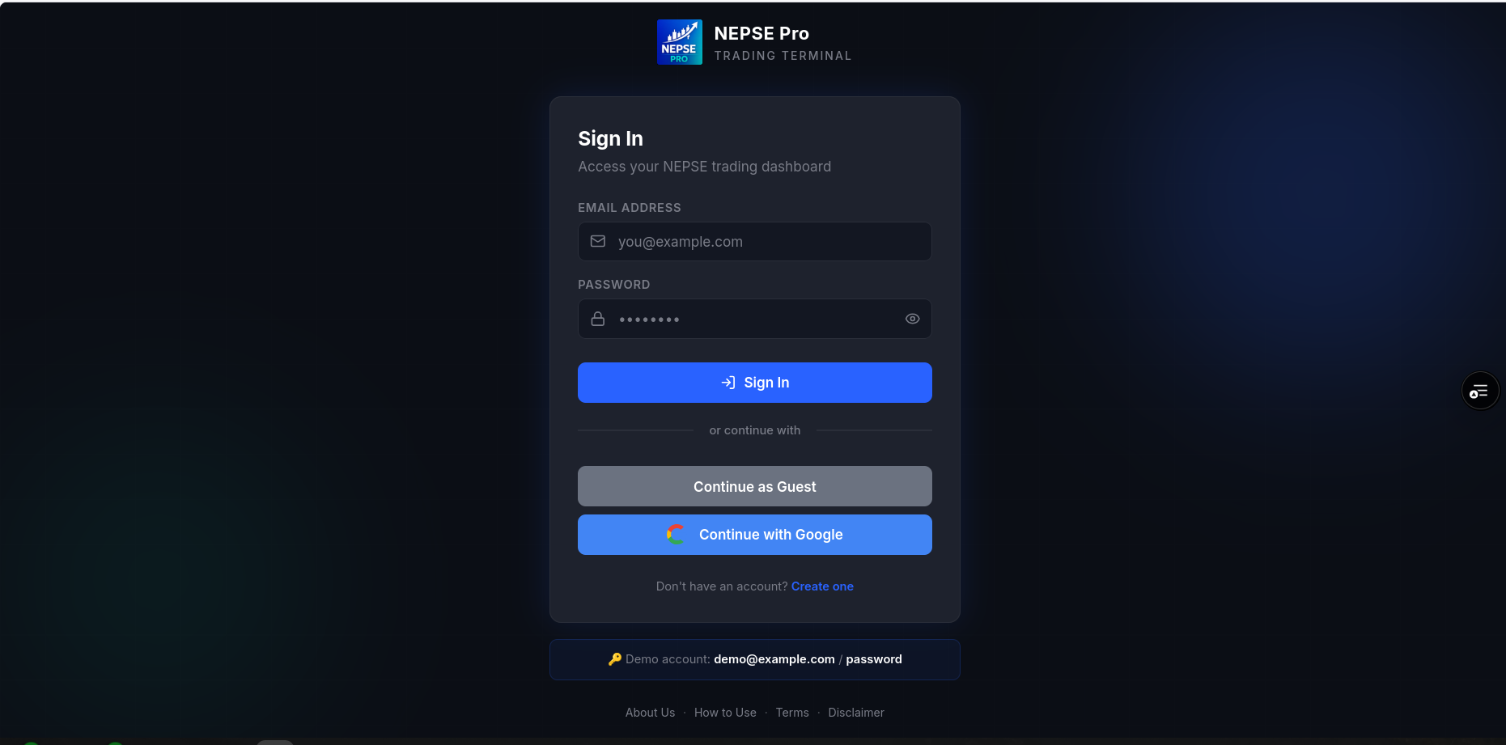
Appendix 5: Registration Page
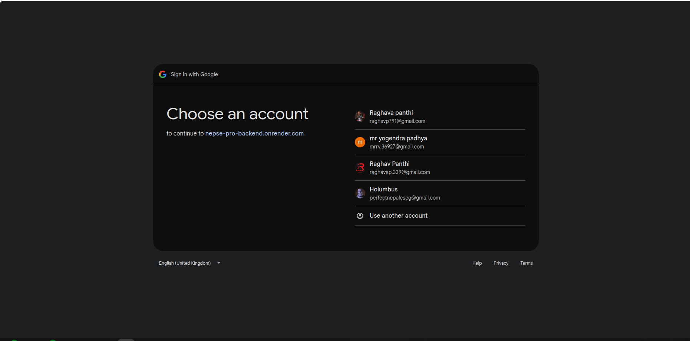
Appendix 6: Sign in though Google OAuth Page
Appendix 7: Sign in though creating account

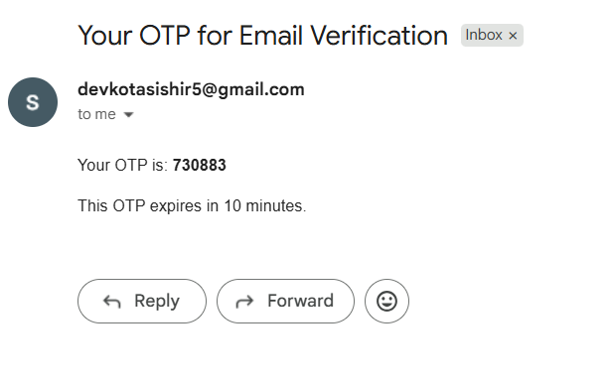
Appendix 7: OTP for Email Verification

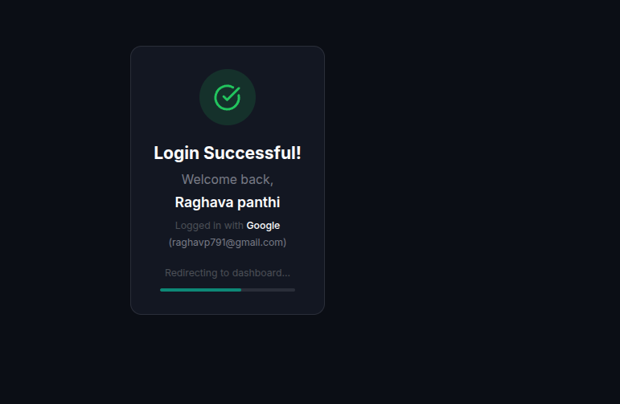
Appendix 8: Login Successful

Appendix 9: Nepse API

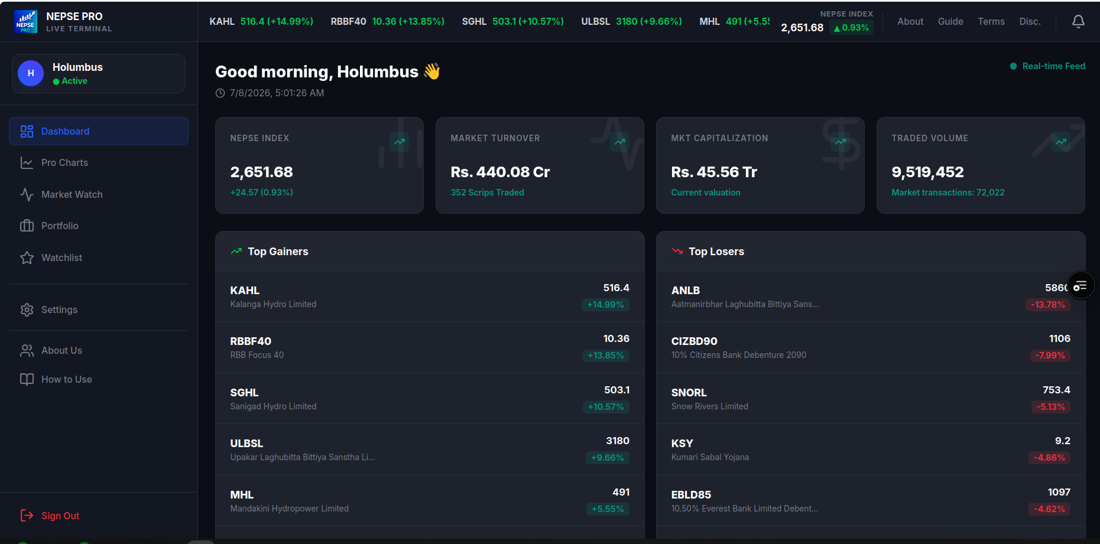
Appendix 10: Dashboard
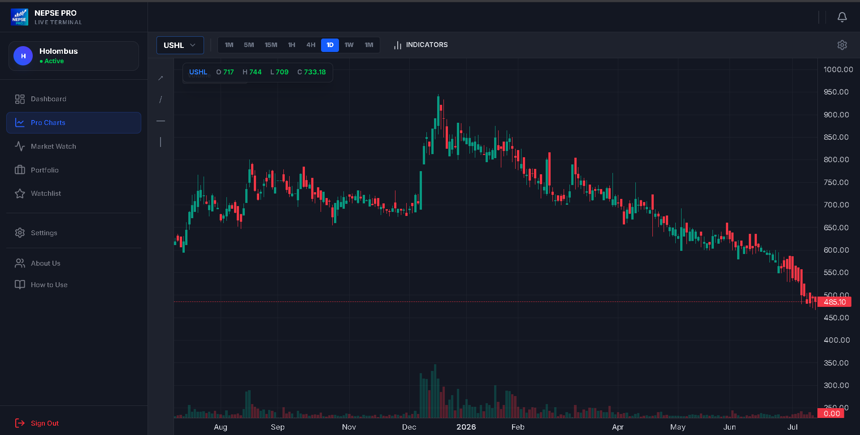
Appendix 11: Charts View without indicators

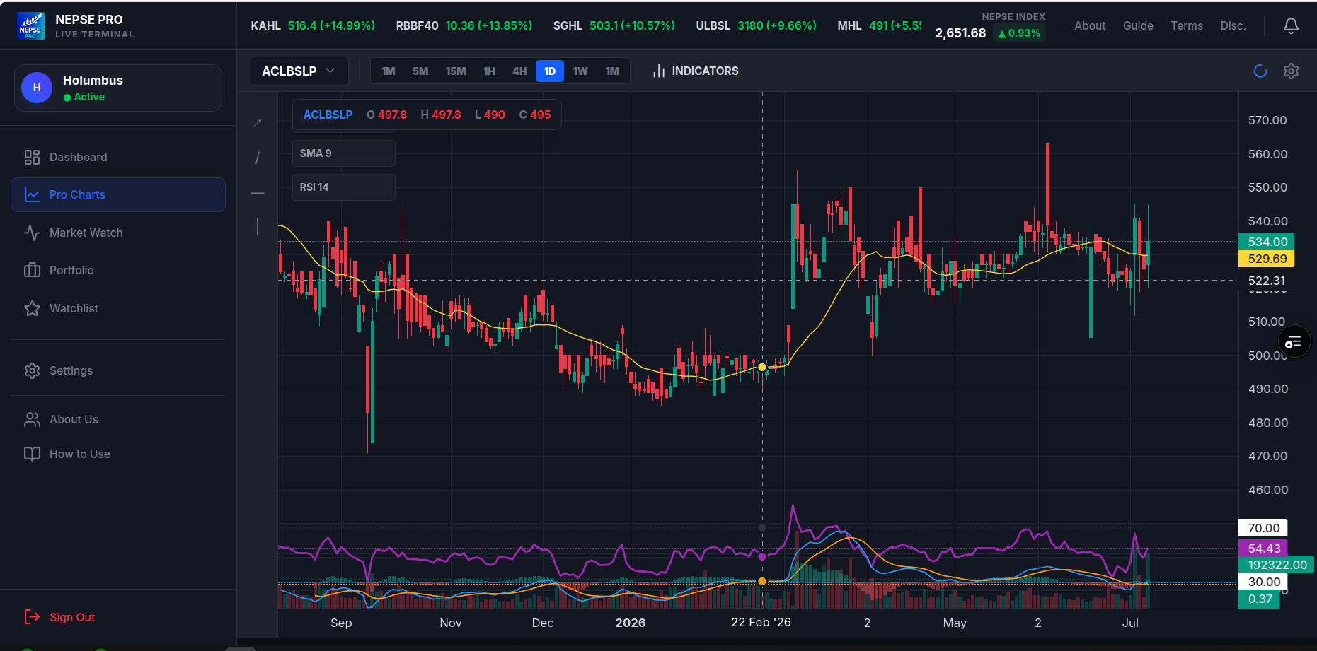
Appendix 12: charts view with indicators

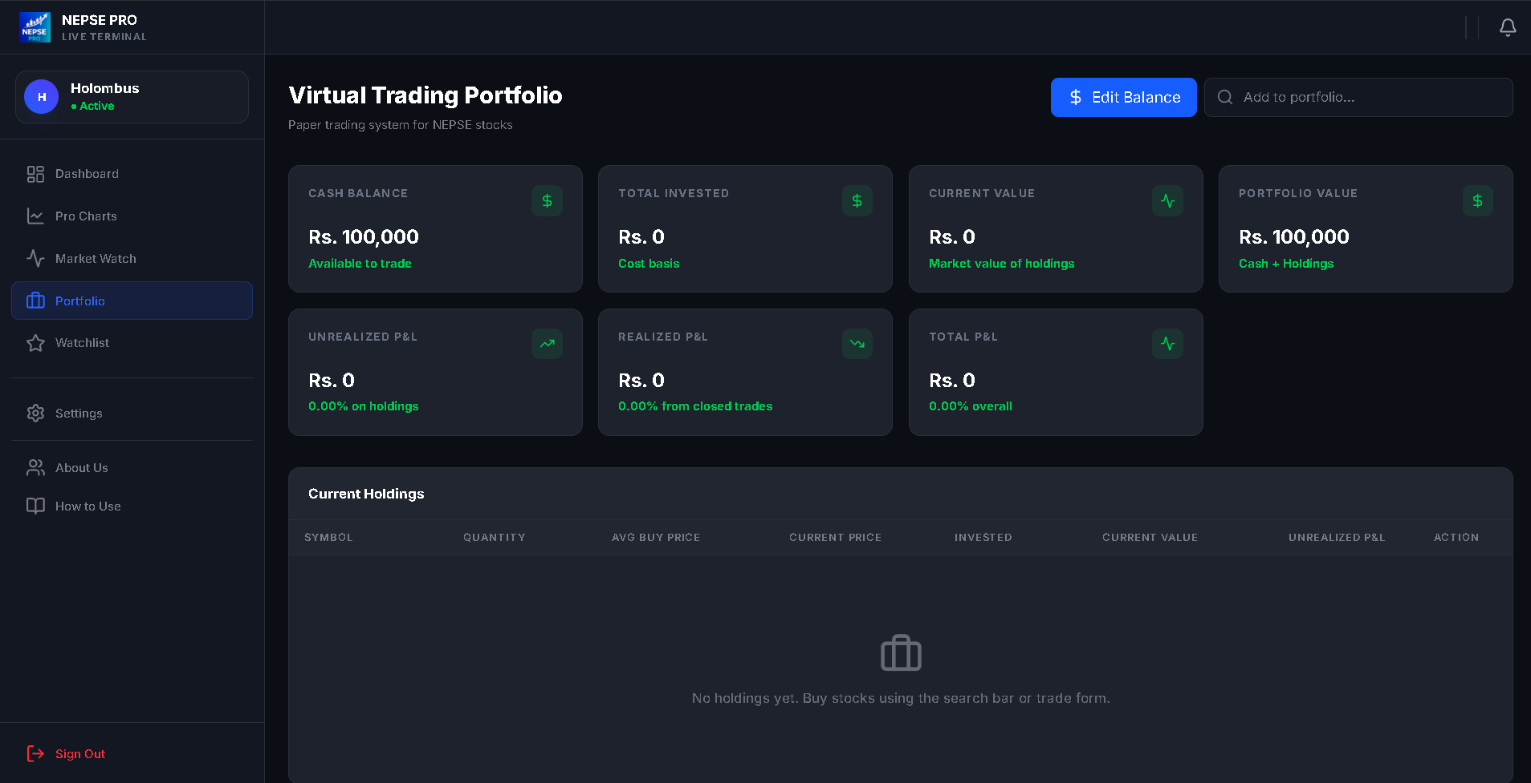

Appendix 13 : Portfolio Page
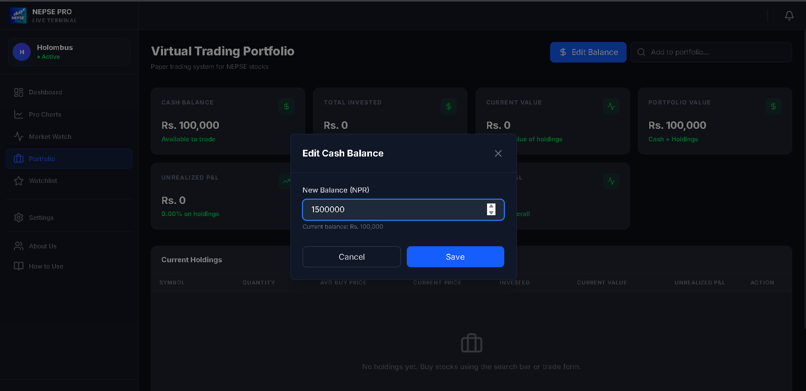
Appendix 14:Editing cash balance

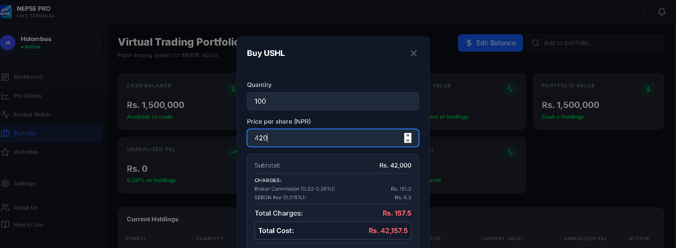
Appendix 15: Buying stock
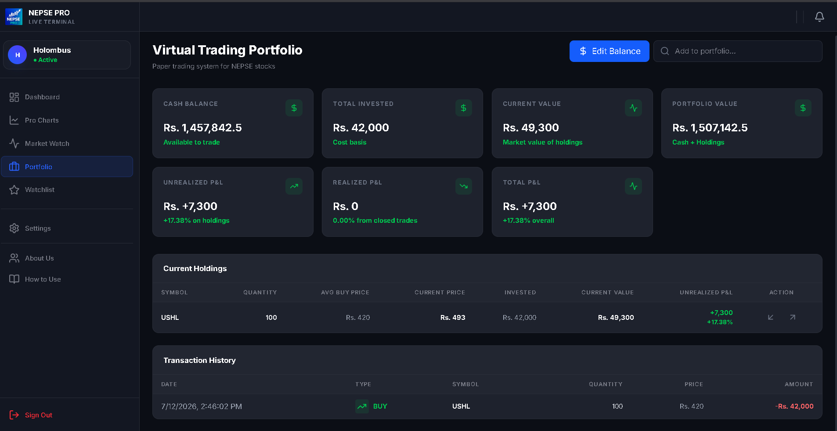
Appendix 16: Protfolio after Buying
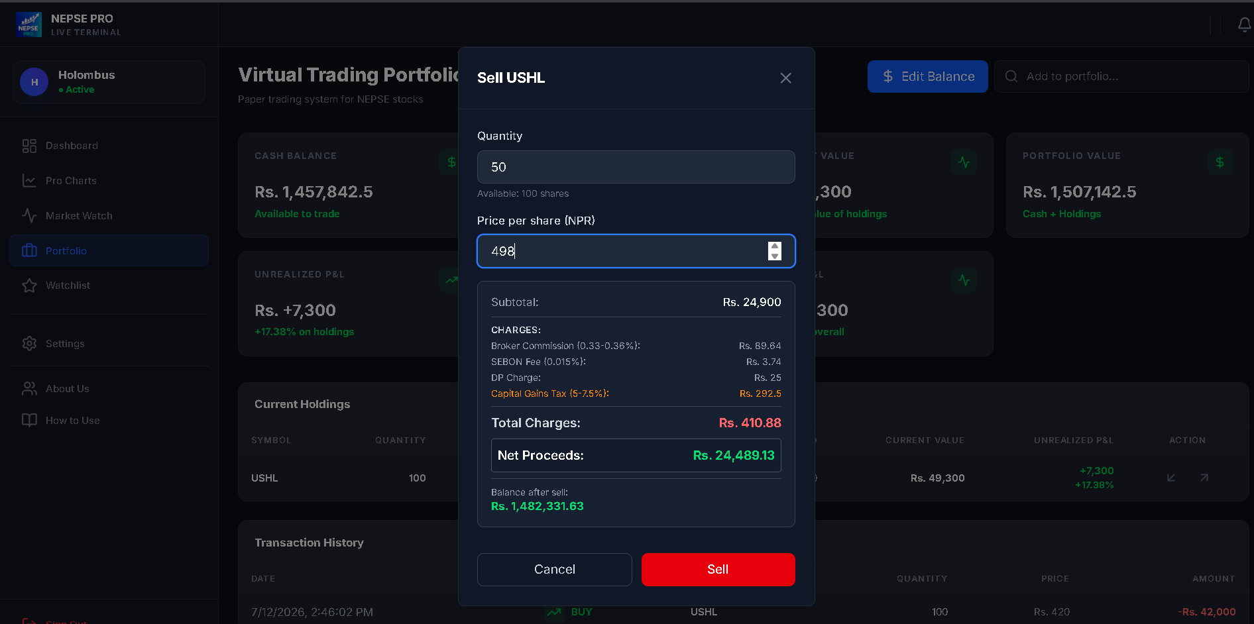Appendix 17: Selling stock
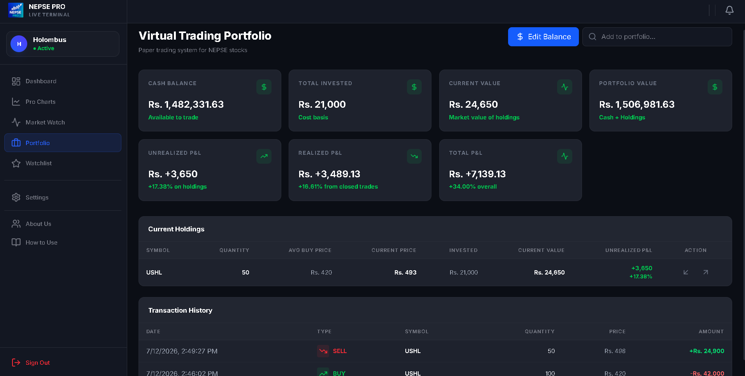
Appendix 18: Protfolio after selling

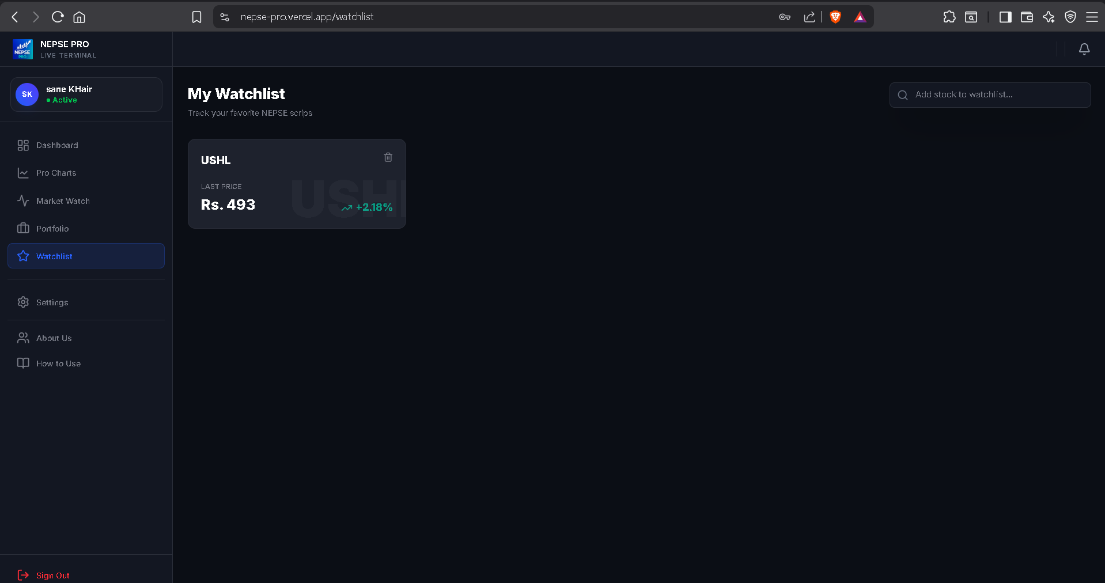

Appendix 19: Before adding Watchlist
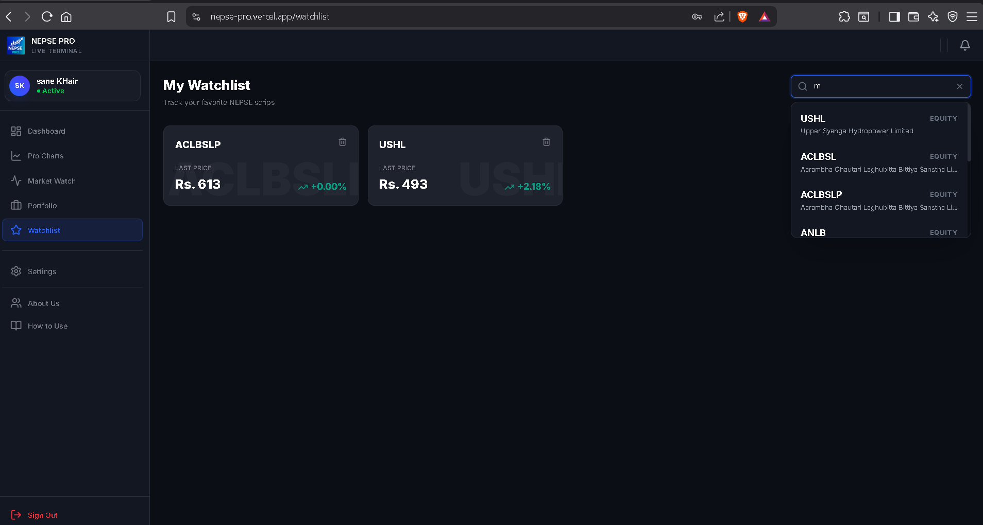

Appendix 20: After Adding Watchlist

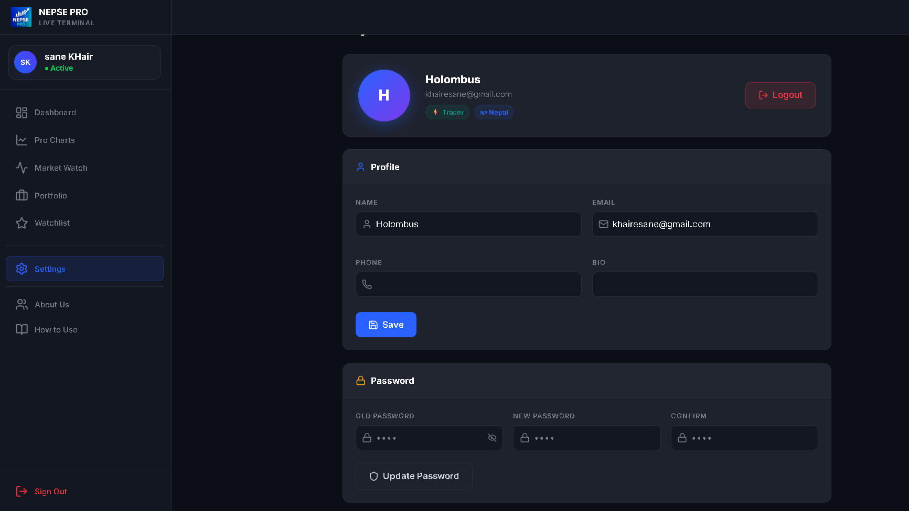
Appendix 21: Setting page

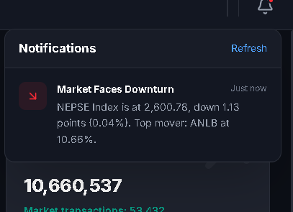
Appendix 21: Realtime notification

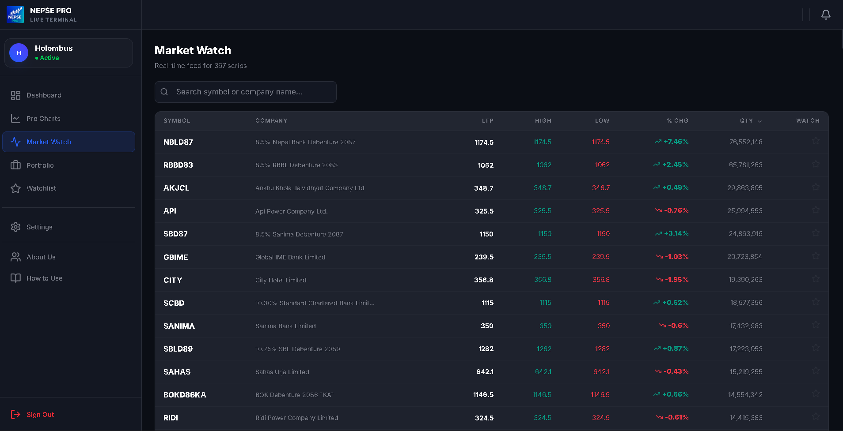
Appendix 22: Market watch Page
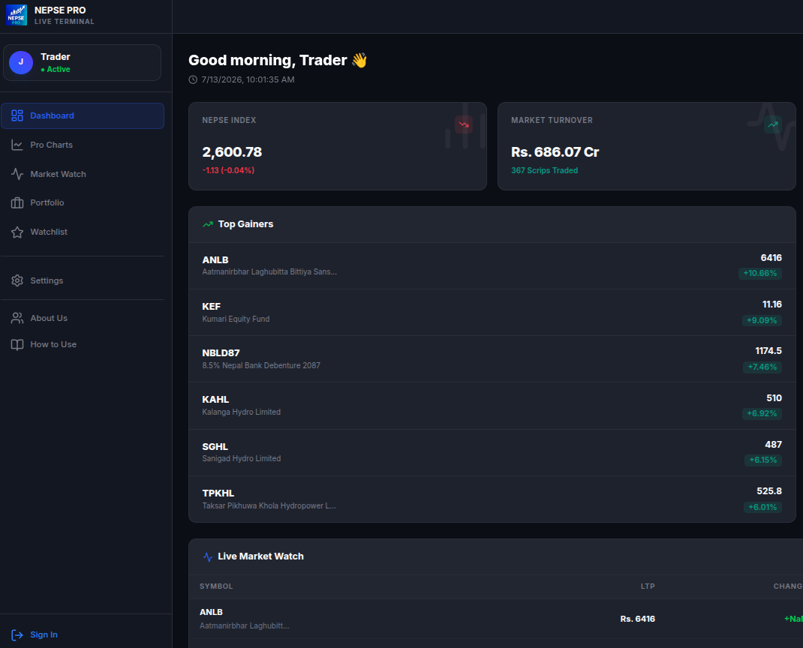
Appendix 23: Guest account view

